**加拿大工程院专家简历**

**首页部分**

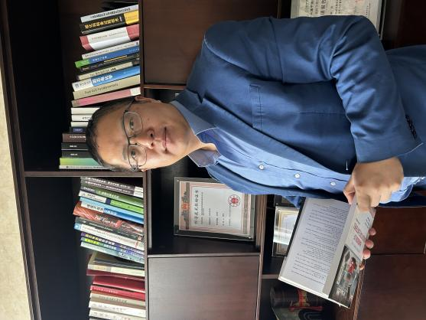**Photos（The photo must be high-definition of the journal in hand）**

1. **Marital status: married**
2. **Office Address:BuildingJ15, Jianghan University, Wuhan China** 430056
3. **Website:（Link to profile）**https://www.linkedin.com/in/ming-xie-12541016/

**正文部分**

1. **EDUCATION**

09/2004 – 05/2010 Michigan Technological University, Houghton, MI

* Ph.D. in Engineering Physics

09/2000 – 06/2004 Beijing Institute of Technology, Beijing, China

* B. S. in Optical Engineering

1. **DISTINCTIONS AND AWARDS**
2. Second Prize of Science and Technology Progress Award of China Chemical Society
3. First Prize of China Invention Association
4. Second Prize of Science and Technology Progress Award of Hubei Province
5. Second Prize of Science and Technology Progress Award of Chinese Society of Particuology
6. **EXPERIENCE**

NingBo Enerol Nanotechnologies, Inc. NingBo, China

CEO October 2016 – Present

JiangHan University Wuhan, China

Adjunct Professor January 2020 – Present

1. **HEAD OF APPLIED PROJECTS:**

**Supervision of Master and Ph.D.Theses**

**Master Theses---- XX,Ph.D.Theses---XX**